FACTS REGARDING THE PROPOSED TIF – TAX INCREMENT FINANCING DISTRICT
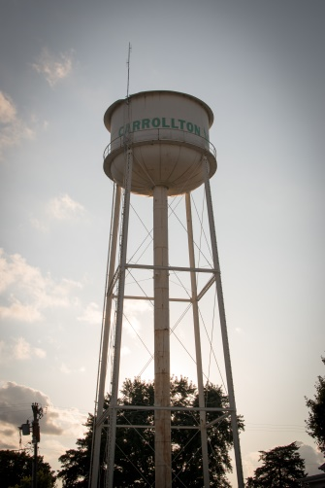

What is Tax Increment Financing, (TIF)? Tax Incremental Financing (TIF) is a state program that allows cities to provide direct financial assistance for community-enhancing development projects.

Why implement a TIF? TIFs do not raise property taxes, rather they capture a fixed amount of revenue to be spent inside the TIF district to increase value, aesthetics and nuts-and-bolts infrastructure like water and sewer mains, sidewalks, etc.

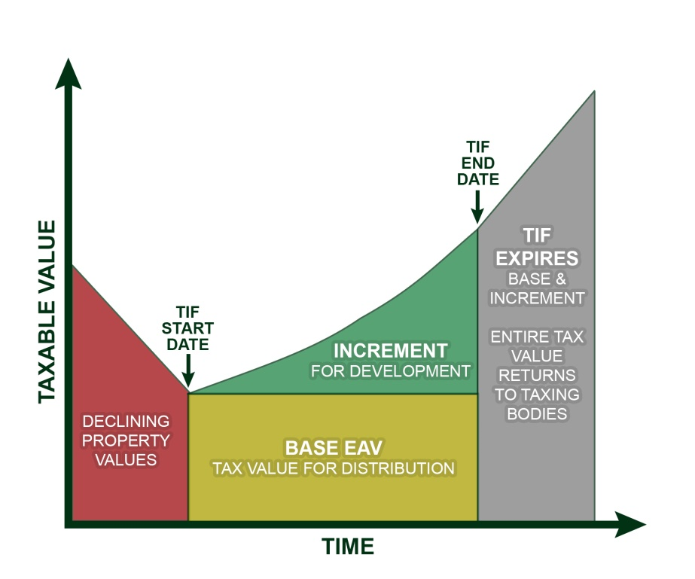
How it works. This graph shows how a TIF operates. At the start time, officials create the BASE number for property taxes that will flow to the city, county, schools, fire department, etc. These entities will get the same amount over the life of the TIF. Taxing Districts will not lose any current monies as a result of the TIF. Ultimately the TIF is designed in part to increase taxing district’s revenues over the long run. As property gains in taxable value, money above the BASE number is funneled to the TIF, which is used for infrastructure purposes. TIFs do not raise property taxes, rather they capture the gain which will to be spent inside the TIF district to increase value, aesthetics and nuts-and-bolts infrastructure like water and sewer mains. When the TIF expires, the entire value -- BASE plus Increment is returned to the tax rolls of all the taxing jurisdictions.

The TIF district must meet specific requirements identified by Illinois statute to qualify. – All of the parcels in the TIF district have been reviewed to ensure that this area qualifies for this program. According to statute, a TIF district must meet at least 3 of 13 qualifying criteria to qualify – and this area meets 8 of the criteria from vacant and aged buildings, to aging infrastructure in the map area.

The term of the TIF district is 23 years. – By statute, the term of the TIF is limited to a maximum of 23 years, but can be retired sooner. The term can only be extended by approval of the Illinois Legislature.

The TIF will NOT “cap”, raise or lower your real estate taxes. – It doesn’t matter if you are IN OR OUTSIDE of the TIF map area. Taxes for individual properties will be determined no differently than they have in the past. Local assessment officials determine each property’s assessed value as prescribed by the Illinois Property Tax Code.

The revenues for use in the TIF area are created from gain in property value within that map area. – A TIF district’s revenues come from the increased assessed value of property and improvements that occur within the TIF district. As new properties develop in the TIF district or dilapidated properties are enhanced (not just repaired or updated), the assessed value of those properties increases resulting in new tax revenue (tax increment). This revenue can only be used in the TIF district for enhancements or updates in that area as stated by Illinois statute

All taxing entities (school, city, etc.) will likely continue to receive more money each year than the prior year. - Because Greene County is subject to Property Tax Extension Limitation Law, (PTELL), in general - the future revenues for each year is based on the amount of tax revenue that they received last year PLUS an increase based on the Consumer Price Index (CPI) or 5% - whichever is less. The annual revenue increase can also be enhanced by new property (any increase in assessed value). Even if assessed values decline, it is likely all taxing entities will still receive an increase in revenue based upon the CPI.

The city has not considered nor has any plans to acquire properties in the TIF area. – The rumors of the use of eminent domain are completely untrue. The city has plenty of property to maintain without acquiring additional property.

TIF Redevelopment Plan & Project Overview. For over 10 years the Carrollton Square and many of its surrounding properties have been in a state of decline. As such, over the past year, the City Council has been investigating options to revitalize the stagnant square/business district. The option currently under consideration is a redevelopment plan for the Carrollton Square and business district area, funded from the proceeds of a new tax increment financing (TIF) district. The City Council is now seeking vehicles to spur growth in the square/business district. It is hoped that, by making some strategic investments in the district with the aid of TIF (streetscape, infrastructure & building rehabilitation), a seed of growth may be planted which will help revitalize the Carrollton Square corridor. A strong square/business district can help relieve pressure on residential property taxes and diversify and strengthen the City’s tax base.

Specific Goals:

- Maintain Carrollton’s “Small Town Feel” while enhancing its appearance and use of Carrollton Square as an event space, gathering space, and public square.
- Increase Carrollton’s tax base, including redevelopment of housing sites and enhancement of current and future businesses.
- Promote the natural assets of Carrollton and Greene County through increase exposure and name recognition throughout the region. Some possible business ideas include regional food exports, such as specialty crops from local farms, including Mary Michelle wine, pecans, flowers, and pumpkins/the pumpkin farm “experience” to larger markets in St. Louis, Springfield, and Alton.
- Leverage a vibrant group of local business and civic leaders to continue to drive the community towards a revitalization of the city that has been stagnant for many years in hope of increasing the tax base for the entire city and county.

